Math II Name_____________________________
Unit 7 Day 4: Graphing inequalities Period__________Date______________

Graph the system.
1. $x>-1$ 2. $-x+y≤-3$
$x<3$ $y≥x+4$
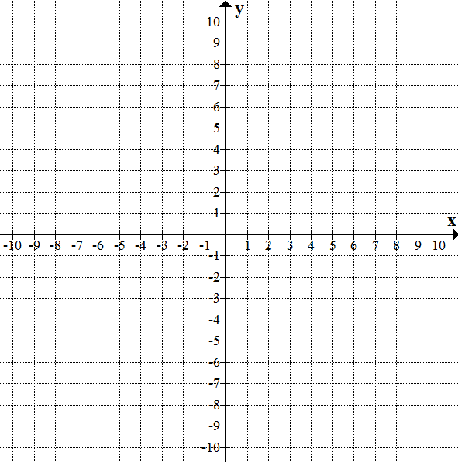

3. $y>-x-4$ 4. $3x-2y>-4$
$y≥\frac{1}{2}x -2$ $2x+4y<12$

5. $y<-{\left(x-2\right)}^{2}+1$ 6. $y≥{\left(x-1\right)}^{2}$
$y≥ -x+1$ $y<x-3$

7. $x^{2}+y^{2}≤25$ 8. $y≥-1$
$4y<3x$ $x>-2$
$y≤-\frac{1}{2}x+2$

Solve using any method.(Show work.)
9. $2x+3y=-3$ 10. $y=-7x-16$
$2x+y=7$ $x+4y=-10$

11. $-4x-3y=-14$ 12. $6x-2y=30$
$-8x+y=14$ $-10x-3y=7$

13. Karen makes $5 per hour babysitting and $12 per hour giving music lessons. One weekend, she worked a total of 18 hours and made $139. How many hours did she spend babysitting?

